EntityDataSource – Chart

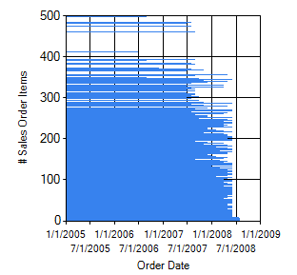

Web.Config

<connectionStrings>

<add name="AdventureWorksLT2008"

connectionString="metadata=res://*/AdventureWorks.csdl|res://*/AdventureWorks.ssdl|res://*/AdventureWorks.msl;provider=System.Data.SqlClient;provider connection string=&quot;data source=.;initial catalog=AdventureWorks;integrated security=True;MultipleActiveResultSets=True;App=EntityFramework&quot;"

providerName="System.Data.EntityClient" />

</connectionStrings>

|  |
| --- |
| EntityDataSource |
| <asp:EntityDataSource ID="SalesOrderItemsEntityDataSource" runat="server"  ContextTypeName=""  CommandText="SELECT Headers.OrderDate, SUM(Details.OrderQty) AS SalesOrderItems  FROM SalesOrderHeaders AS Headers INNER JOIN  SalesOrderDetails AS Details ON Headers.SalesOrderID = Details.SalesOrderID  GROUP BY Headers.SalesOrderID, Headers.SalesOrderNumber, Headers.OrderDate"  ConnectionString="name=AdventureWorksLT2008"  DefaultContainerName="AdventureWorksLT2008" EnableFlattening="False">  </asp:EntityDataSource> |

<asp:Chart ID="SalesOrderItemsHistoryChart" runat="server"

DataSourceID="SalesOrderItemsEntityDataSource">

<series>

<asp:Series ChartType="Bar" Name="Series1" XValueMember="SalesOrderItems"

YValueMembers="OrderDate">

</asp:Series>

</series>

<chartareas>

<asp:ChartArea Name="ChartArea1">

<AxisY Title="Order Date">

</AxisY>

<AxisX Title="# Sales Order Items">

</AxisX>

</asp:ChartArea>

</chartareas>

</asp:Chart>

Other EntityDataSource sample with parameter

<asp:EntityDataSource ID="dsSubCategory"runat="server"   
   ConnectionString="name=AdventureWorksModelConnection"   
   DefaultContainerName="AdventureWorksModelConnection"   
   EntitySetName="ProductSubcategory"   
   Select="it.[ProductSubcategoryID], it.[Name]"

Where="it.ProductCategory.ProductCategoryID = @ProductCategoryID">  
    <WhereParameters>  
        <asp:ControlParameter ControlID="ddCategories"   
       Type="Int32"Name="ProductCategoryID" />  
    </WhereParameters>  
</asp:EntityDataSource>